**Food Log**

**Wednesday 16.9.2015**

**Breakfast**

• 400ml of water

• 1 portion of brown rice, vegetables and chicken

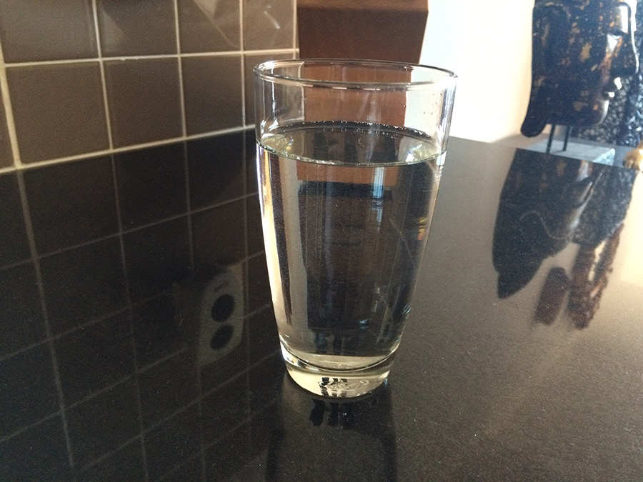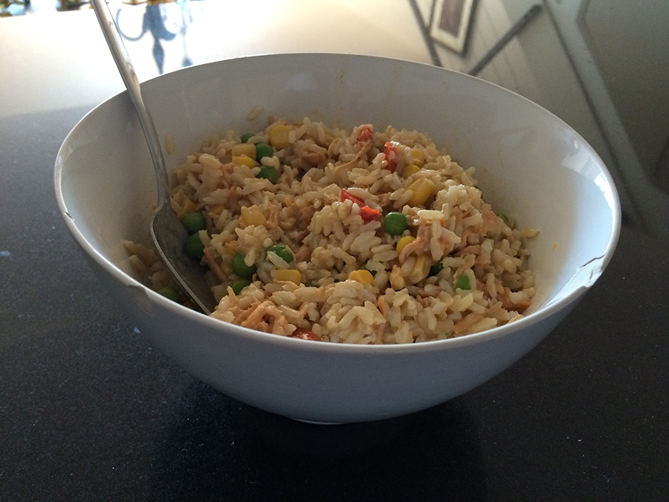

**Lunch**

• 400ml of water

• 1 portion of brown rice, vegetables and chicken

• 1 big cup of tea

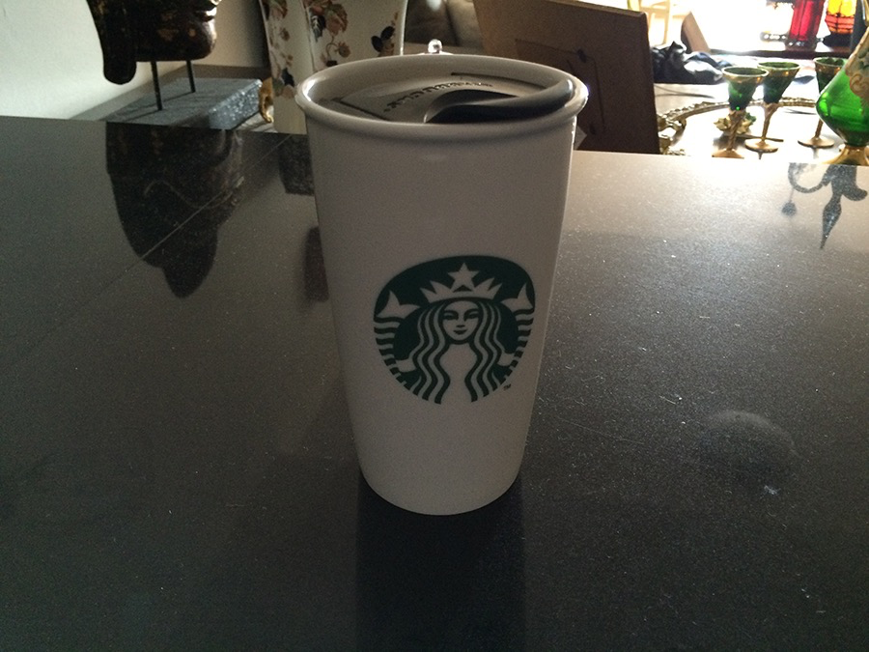

**Mid-afternoon**

• 1 protein shake

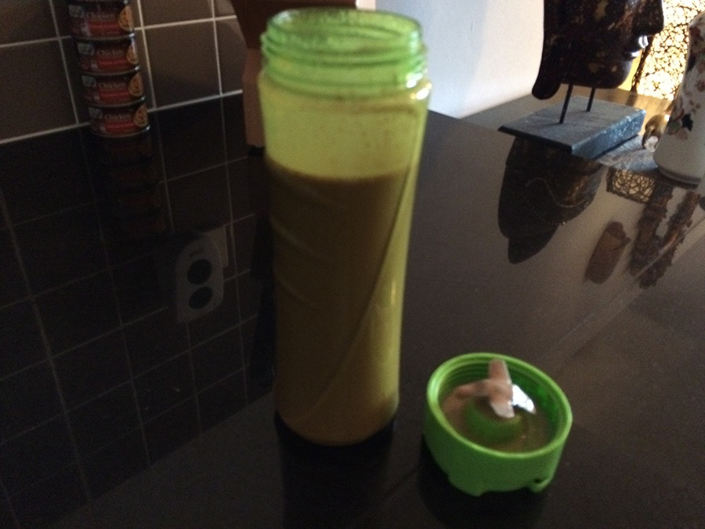

**Dinner**

• 400ml of water

• 1 portion of salad

• 1 portion of wholemeal pasta with vegetables and salmon

• 1 cup of tea

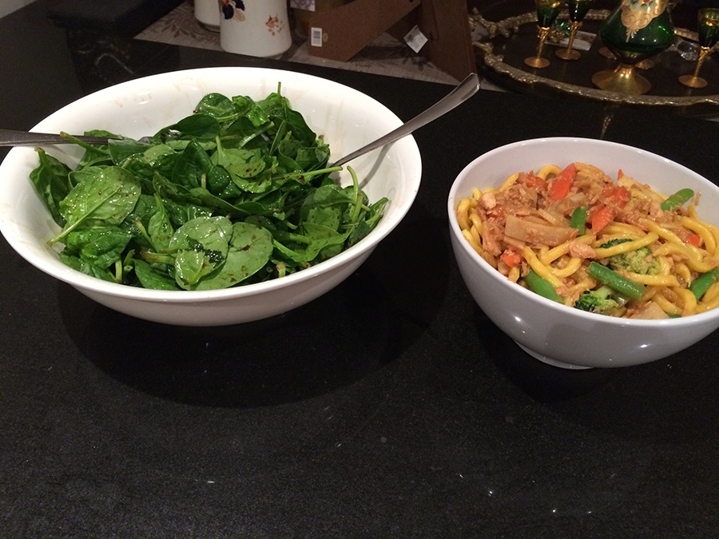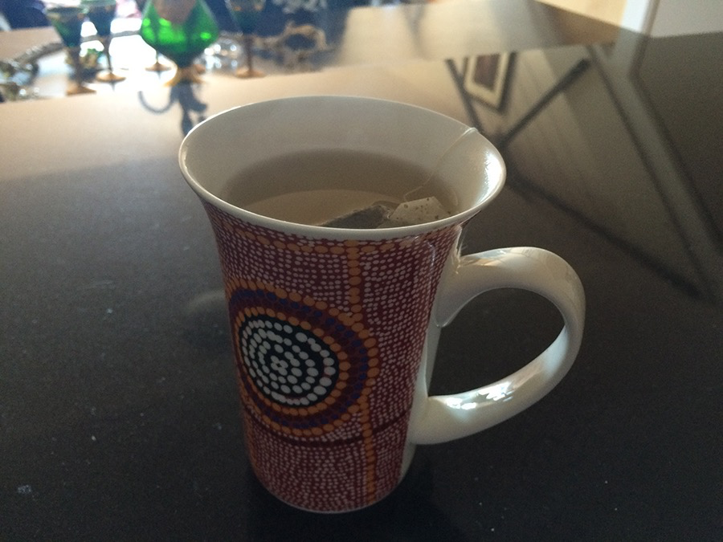

**Thursday 17.9.2015**

**Breakfast**

• 400ml of water

• 1 portion of brown rice, vegetables and chicken



**Lunch**

• 400ml of water

• 1 portion of brown rice, vegetables and chicken

• 1 big cup of tea



**Mid-afternoon**

• 1 protein shake



**Dinner**

• 400ml of water

• 1 portion of salad

• 1 portion of wholemeal pasta with vegetables and salmon

• 1 cup of tea



**Saturday 19.9.2015**

**Lunch**

• 400ml of water

• 1 portion of brown rice, vegetables and chicken



**Mid-afternoon**

• 1 protein shake



**Dinner**

• 400ml of water

• 1 portion of brown rice, vegetables and chicken

• 1 cup of tea



**Reflective Summary**

Despite the fact that I had never done a complete food and liquid ingestion log like this one that we had for homework, it did not show me anything new. Two reasons contributed for this exercise not to bring up anything that I either already knew or were familiar with.

First, since I am diagnosed with Irritable Bowel Syndrome (IBS), I follow a quite strict diet and eat and drink pretty much the same things every day.

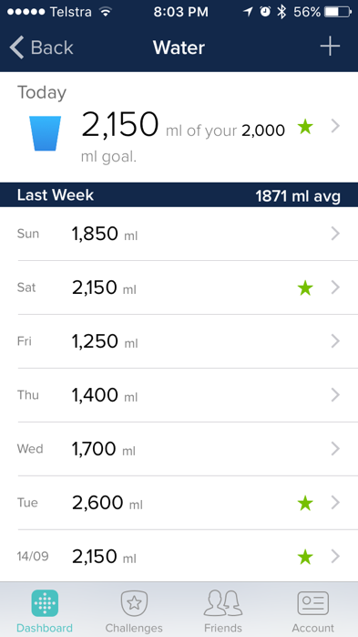Second, since I have a Fitbit band, I already log the liquid I ingest on a daily basis on the Fitbit app on my phone. And as it can be seen in the picture, I ingested 1700ml, 1400ml and 2,150ml of water on Wednesday 16/09/2015, Thursday 17/09/2015 and Saturday 20.09.2015 respectively; which were the days I chose to do this homework exercise.

However, although it did not bring up anything new to me, I acknowledge the importance of such in terms of starting an understanding of how logging activities can be both extremely boring and time consuming; which I am quite sure was basically the point of all this—to start in us a feeling that we can think it through and suggest easier and more enjoyable ways of doing it.

[210 words]

**Camilo Hoffmann Kuschel – 420079224.**